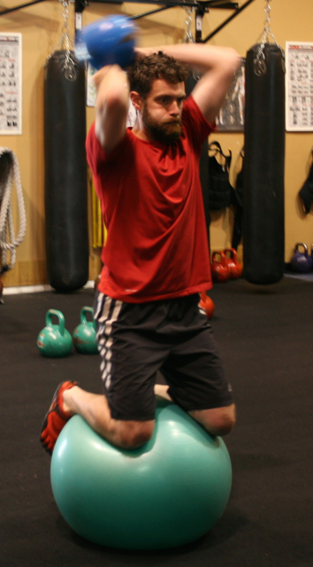

**RULES FOR MIP**

**• TWO categories – Members w Semis & Members w Team only**

**• Points awarded in Semi Private & Team Training sessions only**

**• Point distribution is at Fitness Coach discretion**

• ***Members do not ask*** if they've been awarded a point(s)

• ***Fitness Coaches do not share*** when a point(s) is awarded

• *Winners* receive a *Picas' Margarita card*

• T2BB will meet at *Picas' for MIP celebration* the following month!

• All members are welcome to join at Picas to celebrate

**POINTS ARE RECEIVED FOR ANY ACT OF *ABOVE & BEYOND TYPICAL BEHAVIOR***

**• 1-point**: Distributed to anyone who performs above and beyond their average for that workout

**• 2-points**: Same as above & ***accepted*** a physical fitness ***challenge*** with a positive, can-do attitude

**• 3-points:** Same as above & ***succeeding*** at that ***challenge*** with ***elevated execution***

***Note:*** *A****Physical Fitness Challenge*** *can be one that has been directed by the Fitness Coach or by a member who has accepted their own challenge/goal out or inside the facility and has succeeded with elevated execution and a positive, can-do attitude.*

The MIP program was developed as a positive, promotional challenge and social opportunity for our members to build upon the *‘community within community,’* we like to foster at Training to Be Balanced!

***IT’S ALL ABOUT ATTITUDE & EFFORT!***

**Margarita**

**Incentive THE MIP**

**Program**