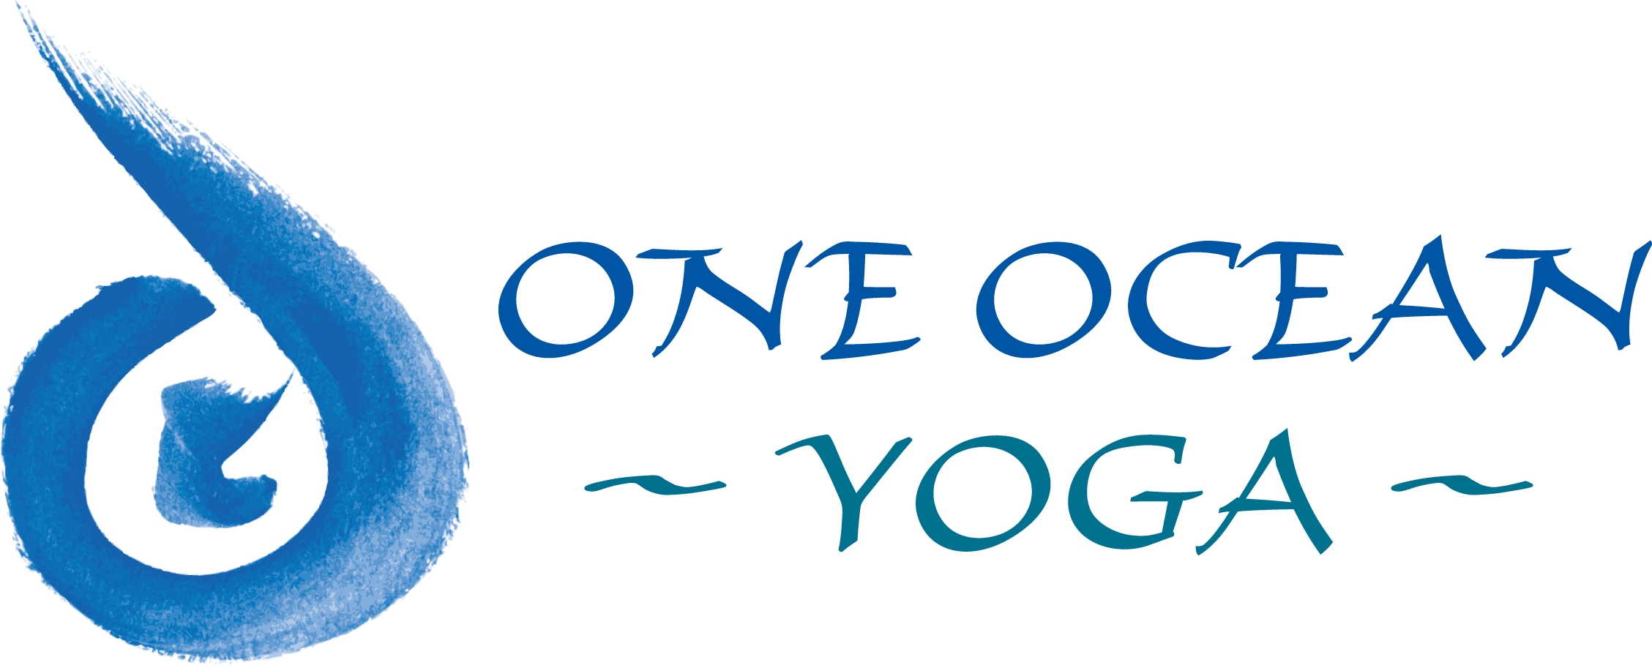
Immersion In the Tradition of Anusara yoga
One Ocean Yoga
Bridgehampton, NY
Immersion Program Application
Please answer all questions completely. Please mail the completed application to:
One Ocean Yoga |  | Send as Attachment to:
PO Box 1468 | Or | Info@OneOceanYoga.com
Bridgehampton, NY 11932

Name:
Age:
Address:
Email Address:
Telephone:
Present occupation:
A deposit of $300 insures your place in the Training. Check one:
_____ Registration fee paid
_____ Registration fee enclosed (check payable to One Ocean Yoga)

Admission into the Training requires an enrollment interview
Check one:
_____ Interview to be scheduled (Call 631-537-5522)
_____ Interview already completed
I. Yoga Background
1. Previous study of Hatha Yoga. Please include:
- Schools, teachers, style of yoga
- Format (classes, workshops retreats, etc.)
- Where, when, how long
- Anusara Yoga training (include hours, teachers, workshops, immersions, retreats, etc)
2. How did your interest in Yoga begin?
3. Have you been exposed to Yoga as a spiritual tradition? Include meditation training and experience, philosophical study, contact with a spiritual community, contact with a spiritual teacher or Guru. Please describe:
4. What practices do you do on your own (meditation, pranayama, asana, Kirtan, Satsang, self-study, study of Sanskrit, scriptures), How often, how long?
5. What aspects of Yoga do you enjoy the most, what inspires you the most?
6. Are you teaching Hatha Yoga professionally? If so, where and when and how many students do you see each week?
7. Why did you apply to this Immersion?
8. What considerations/concerns do you have about doing this Immersion?
9. What are you especially interested in learning more about during the course of this Immersion?
10. In terms of your physical asana practice, how would you assess your strengths and weaknesses on the sticky mat including any physical injuries? (Stay away from self- judgment)
11. Are you currently going through any significant challenges or life transitions?
12. Do you have other skills related to body awareness such as anatomy studies, dance, sports, Pilates, massage, Chiropractic. Do you have other skills i.e. music, arts, counseling?
II. Personal Background
1. Where were you born and where did you grow up?
2. Describe your formal education (use equivalents if educated abroad).
3. Describe other professional training/education.
4. In your studies in high school (or equivalent abroad):
What was hard and what was easy for you? Include homework, exams, reading, and relationship to your class members in your description.
5. Do you like to read? What book(s) have had the most importance or impact on you?
6. What are some of the ways you like to relax, have fun and play?
III. Conclusion:
Please add anything else you would like us to know about you.
The One Ocean Yoga Teacher Training/ Immersion program is dedicated both to the greatness and luminosity of the heart of Yoga and to the teachers who become its carriers.

